School: ____________________________

Check here if Districtwide partner: ______

School Year: ________________________

Date Submitted: _____________________

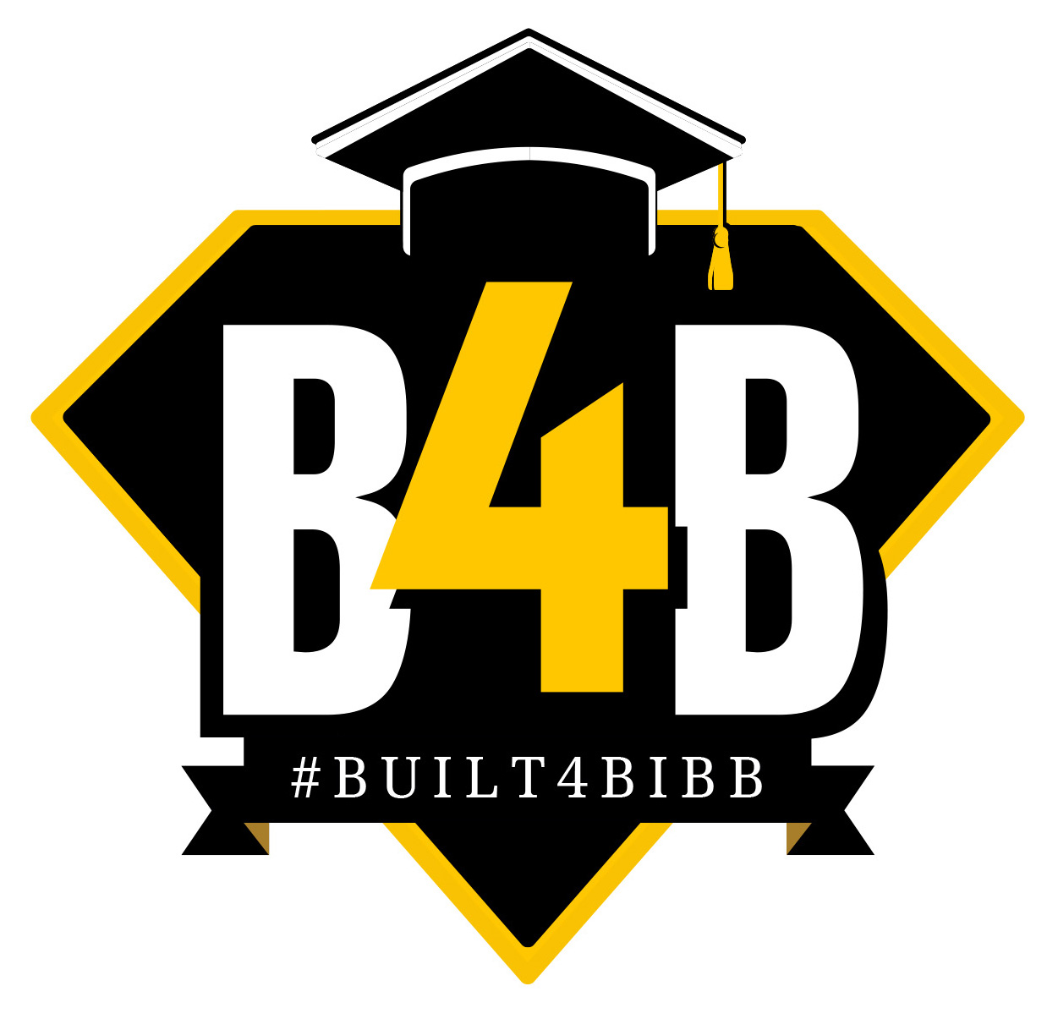
Bibb County School District
Partners in Education

Company/Organization Name: _______________________________________
Contact Person: _____________________________________
Title: _____________________________________________
Mailing Address: ___________________________________________________
Phone: __________________________________________
Email: ____________________________________________

Partnership Opportunities:
Please describe areas of partnership. (Examples include donations of school supplies and funding, participating in career days and mock interviews, providing incentives for student achievement, and providing volunteers for reading and mentoring.)

_____________________________________________

_____________________________________________

_____________________________________________

_____________________________________________

Thank you for taking the time to complete this form and for your interest in our students’ education!

Signature: ___________________________________________________________________________________________________

*If signature is not included, school must attach documentation of partnership when submitting this form.

Please mail this form to: Bibb County School District
Attn: Communications Department/Partners in Education
484 Mulberry Street, Suite 365
Macon, Georgia 31201

You may also email the form to: communications@bcsdk12.net

For more information, please call: 478-765-8548

The Bibb County School District reserves the right to refuse to partner with any person, corporation, company, etc. and to refuse to accept any donation or gift through the Partners in Education program that does not contribute to the achievement of the mission of the Bibb County School District.

**Note: If a business/organization wants to send flyers or other items home with Bibb County students, they must still receive approval from Assistant Superintendent of Student Affairs Jamie Cassady (Jamie.Cassady@bcsdk12.net).

